2a) Data Types:
Write a Java program to store and display the following details of a rooftop solar system:
- Panel ID – integer
- Energy generated in kWh – decimal value
- Number of solar panels – integer
- System status – character
Use appropriate Java data types for each value and display all the details.
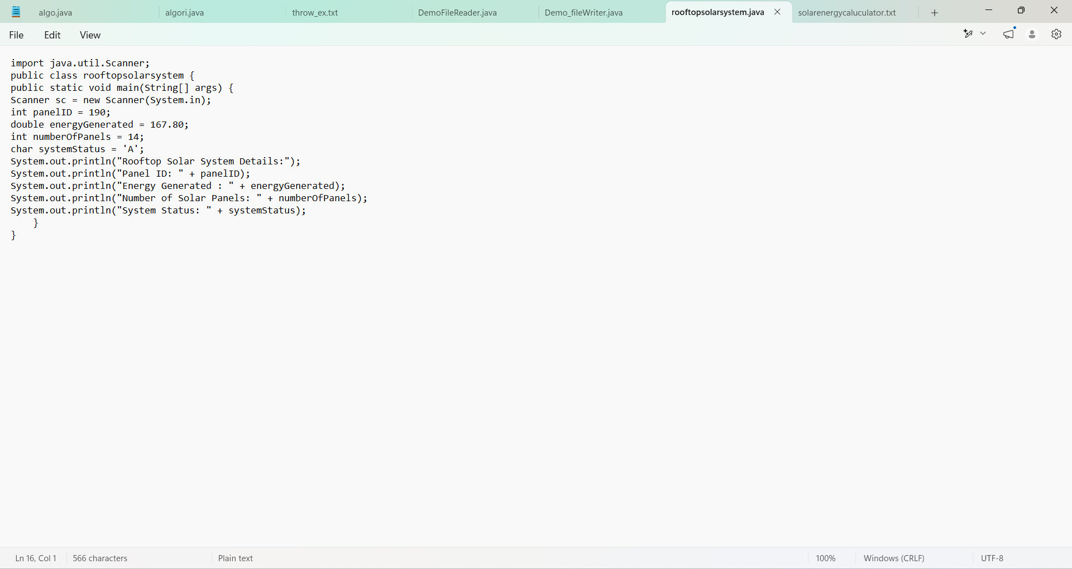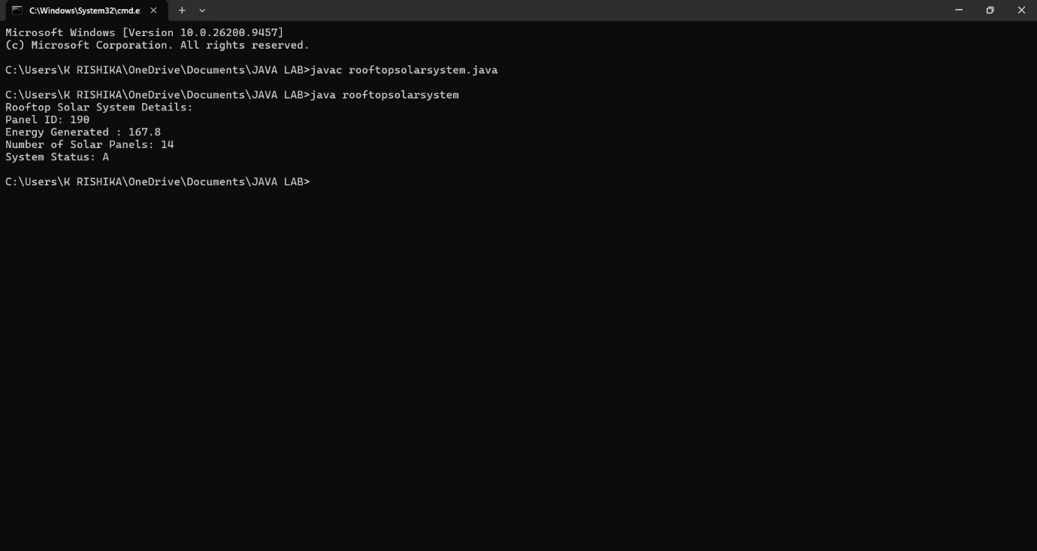

2b) If-Else Condition:
Write a Java program to monitor the energy generated by a rooftop solar system. Read the energy generated in kWh.
- If the energy generated is 10 kWh or more, display "Good Energy Generation".
- Otherwise, display "Low Energy Generation".
Use an if-else statement. 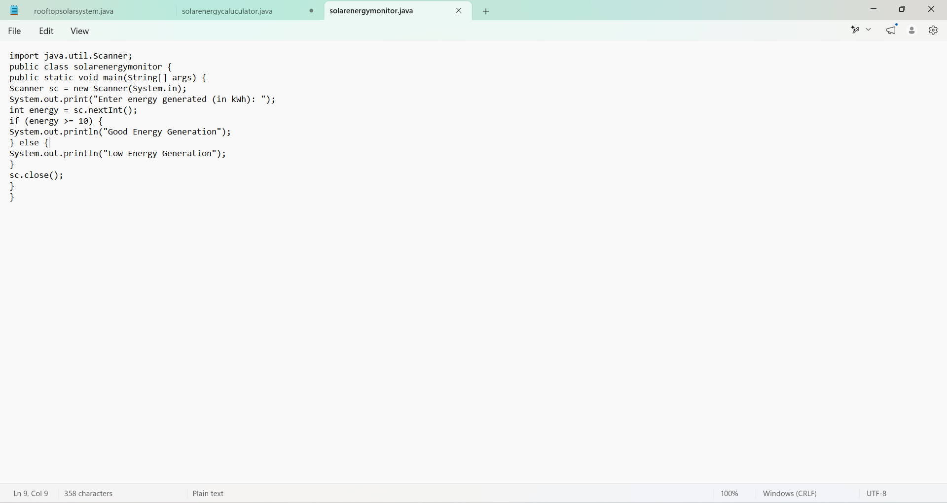 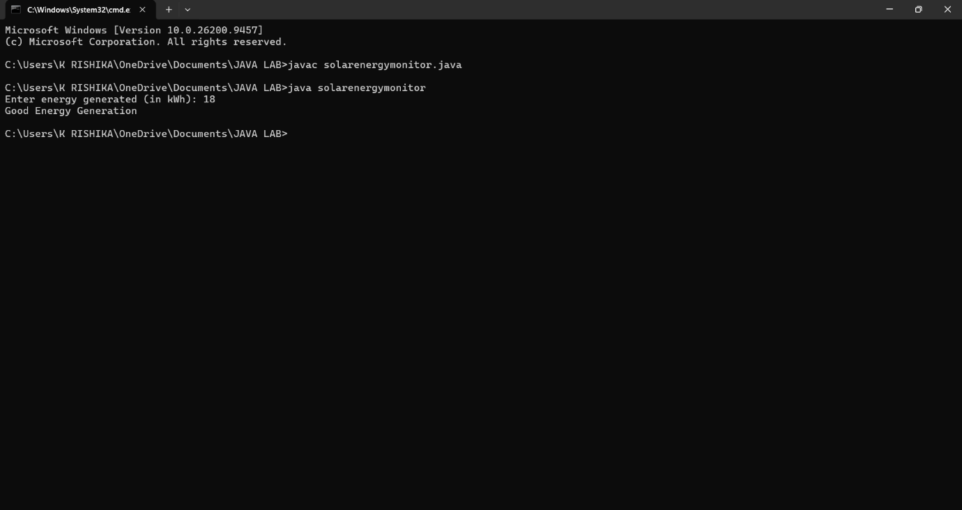

2c) Methods:
Write a Java program to calculate the total energy generated by a rooftop solar system using a method.
Create the following method:
calculateTotalEnergy(double morningEnergy, double eveningEnergy)
The method should return the total energy generated. Read the morning and evening energy generation values from the user, call the method, and display the total energy generated.
